Ulvi Bajarani

SID 20539914

CSCI 6345 – Advanced Computer Networks

Summer II

Assignment 11

Working on Wireshark: ARP, HTTP, TCP captures, inspecting cookies, getting username and passwords from cookies.

Let’s download WireShark from https://www.wireshark.org/download.html

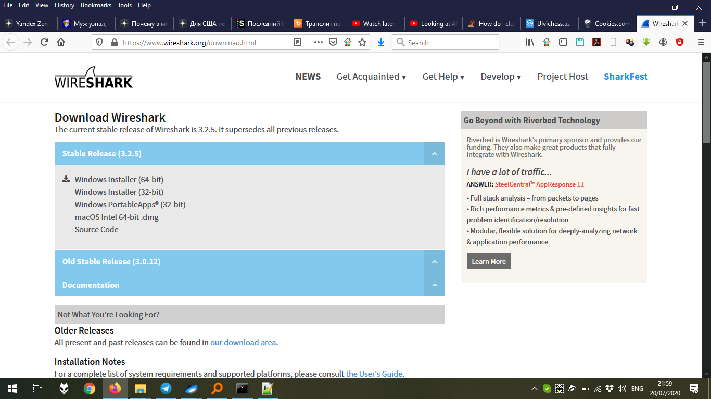

Define the place to save:

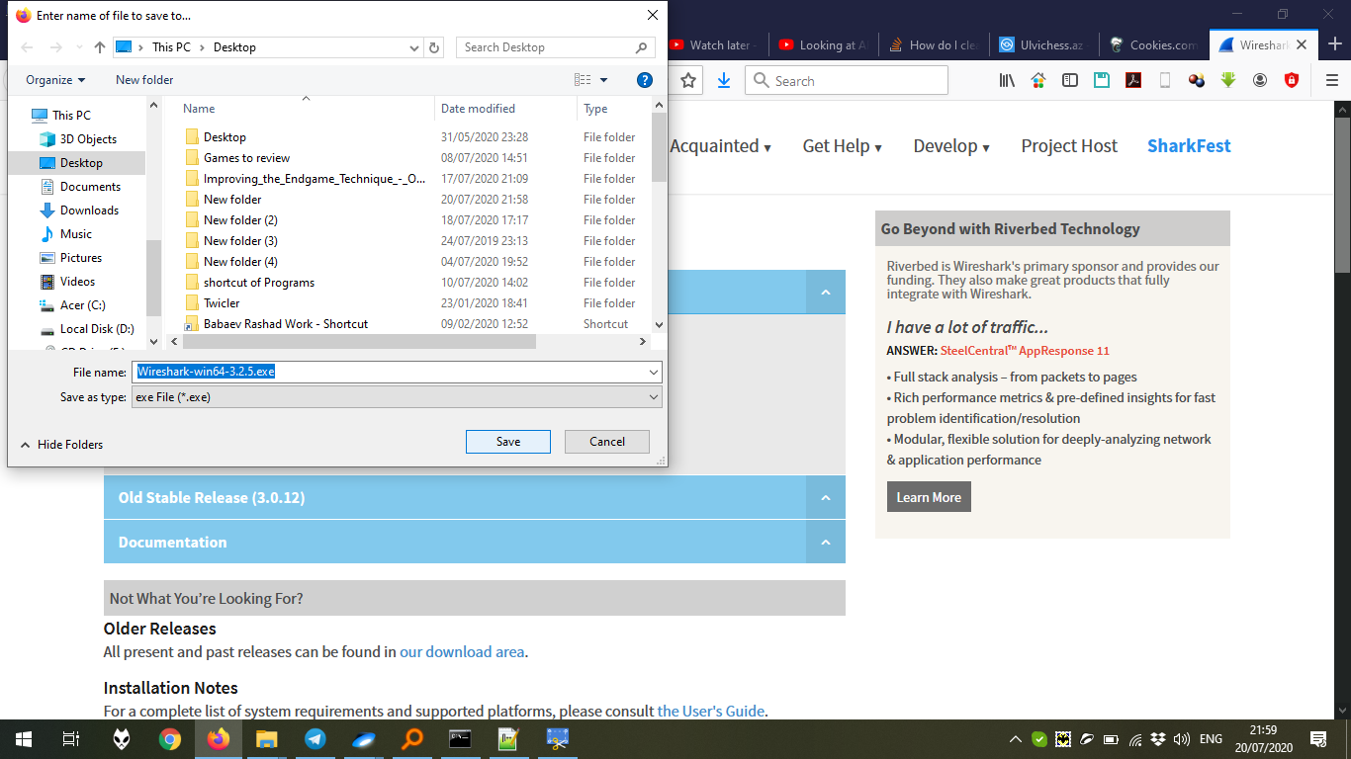

After saving, install WireShark. Click Next:

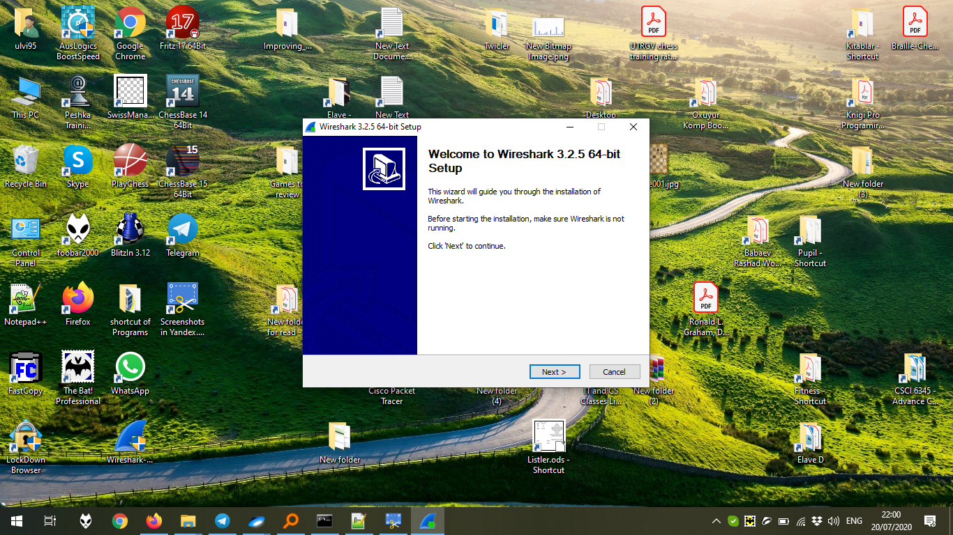

Click I agree:

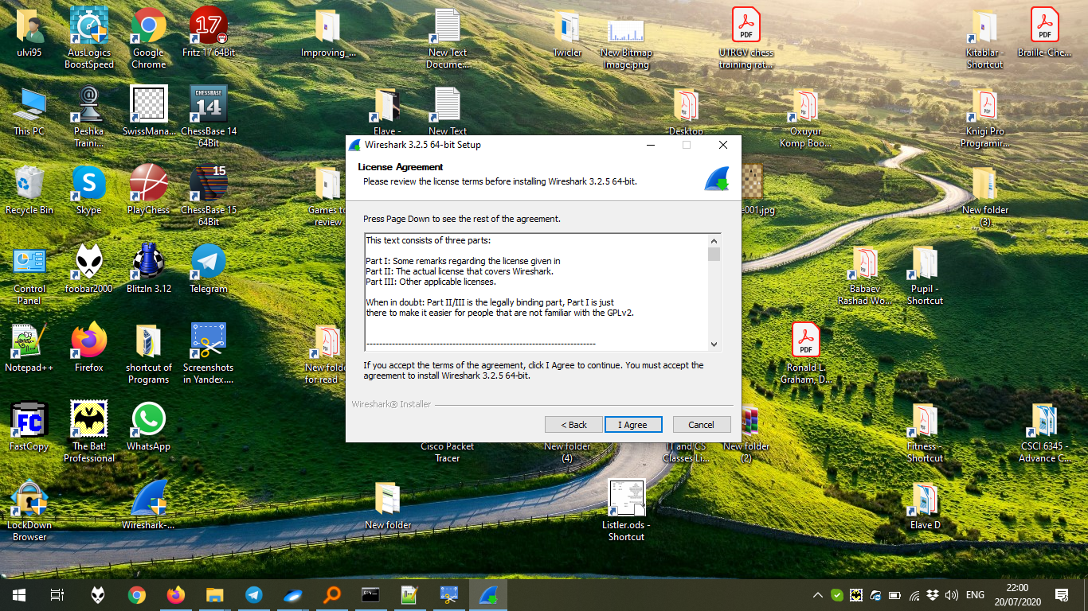

Click Next after choosing the components:

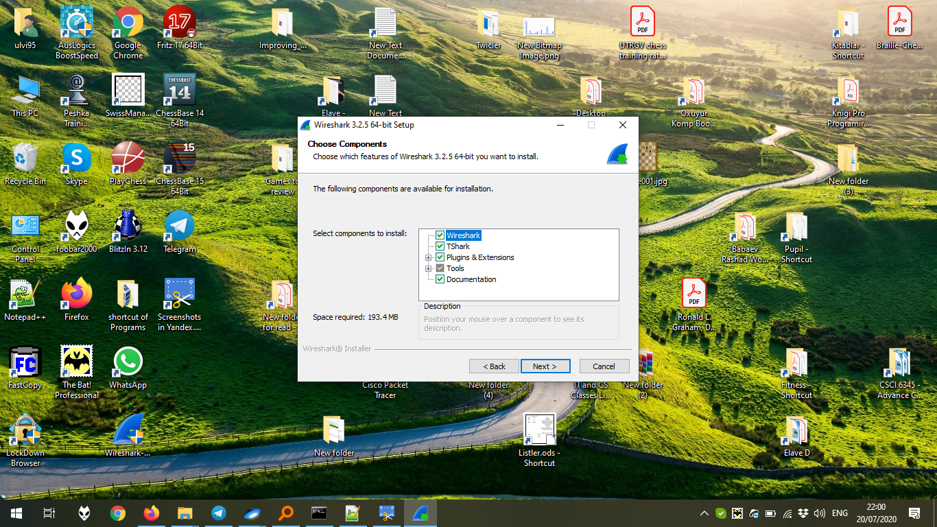

Click Next after choosing proper options:

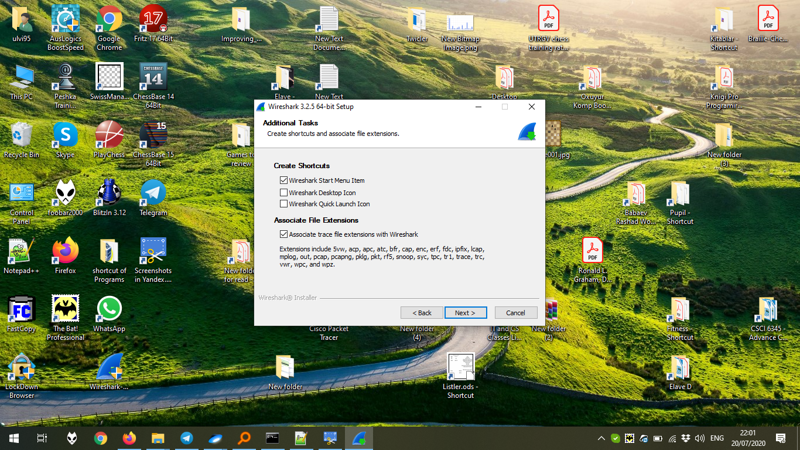

Click Next after defining the Path:

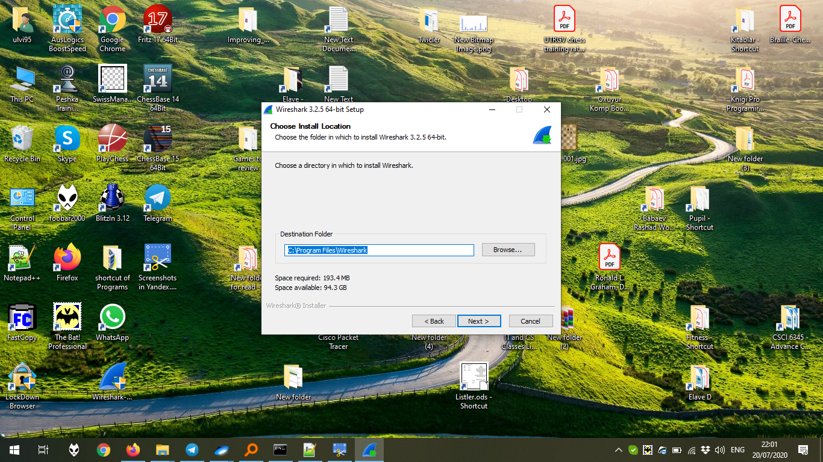

Install Npmap if it is not installed. In my case, it is already installed, so click Next:

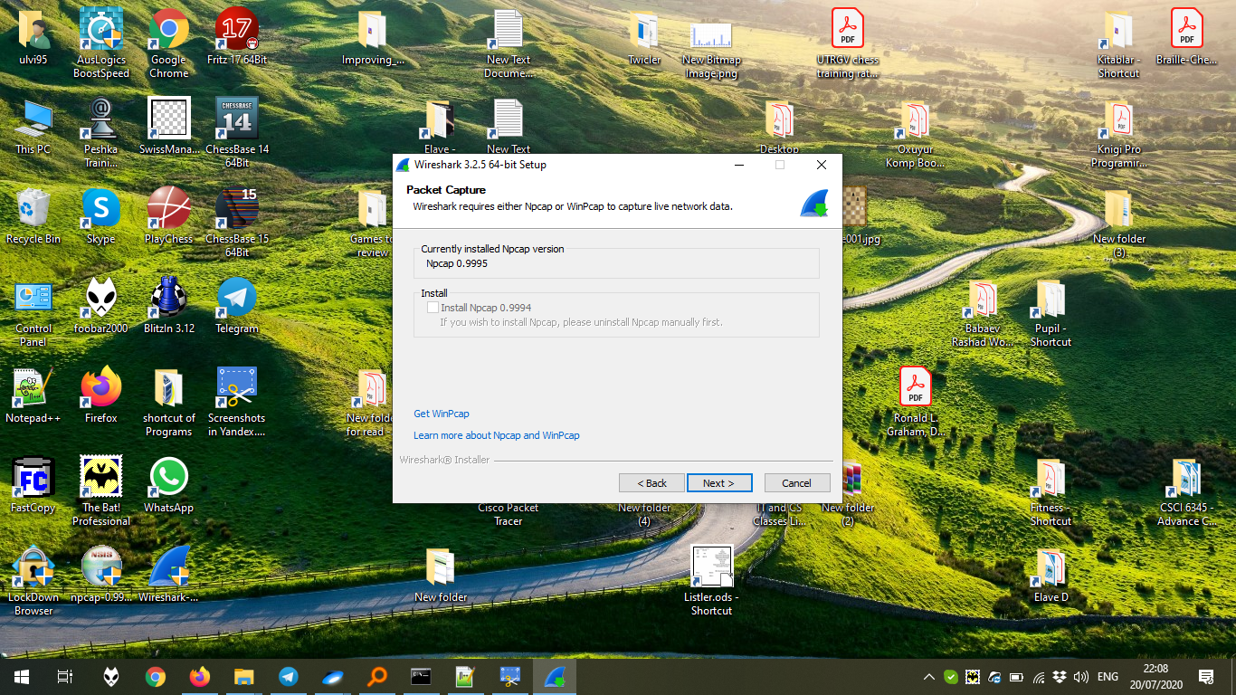

Define if USBCap is needed. Might me missed. Then, click Install:

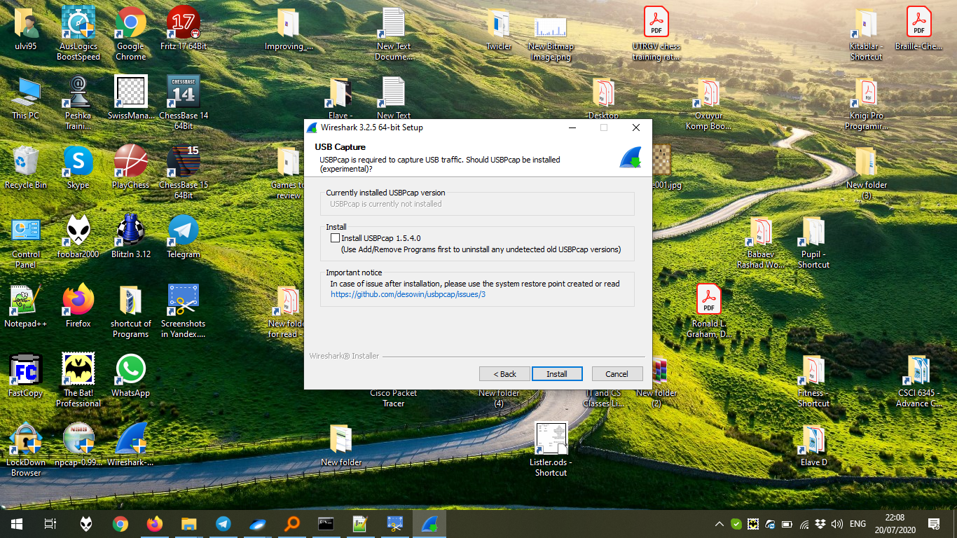

The installation process:

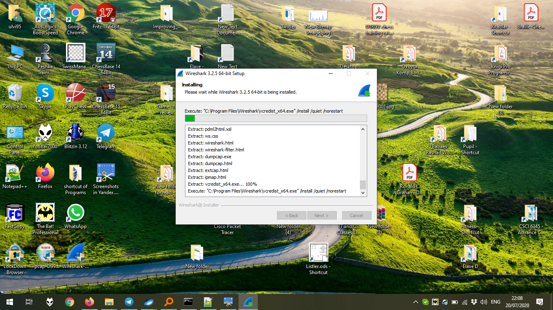

Finish by rebooting either now or later manually:

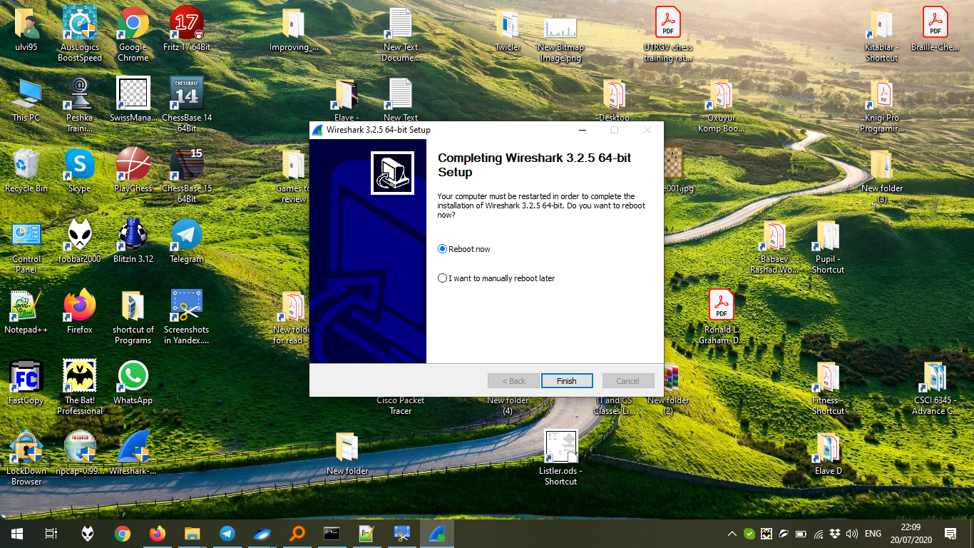

After opening WireShark, choose the interface to capture:

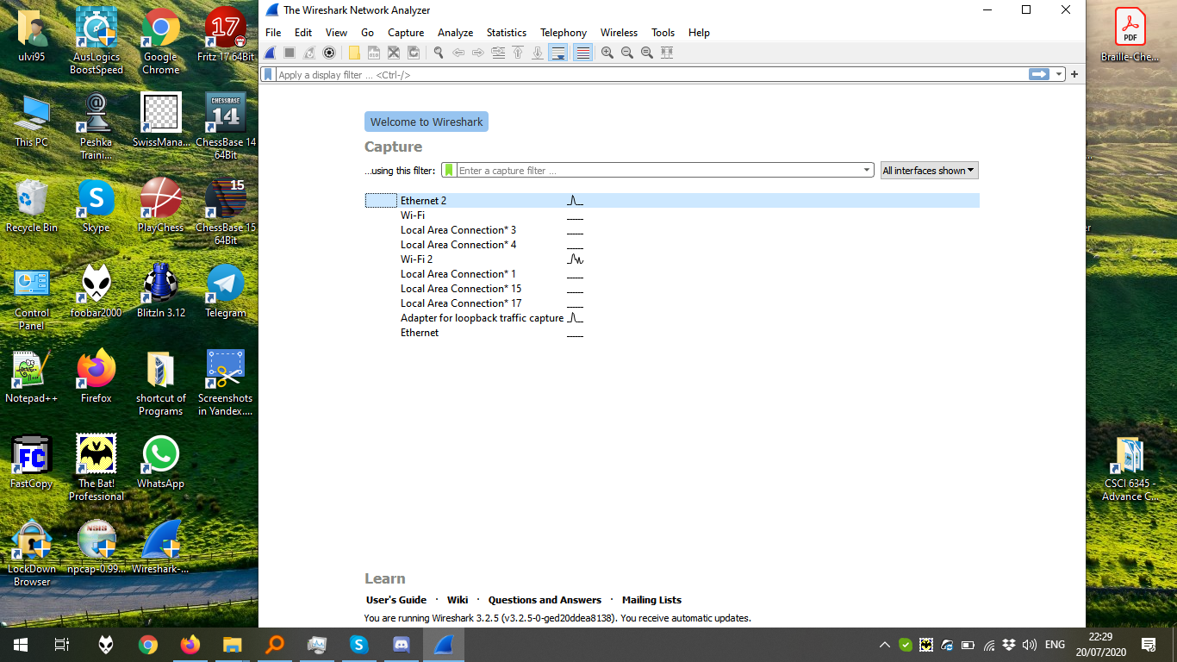

After pinging DNS, filter ARP capture by **arp** filter.

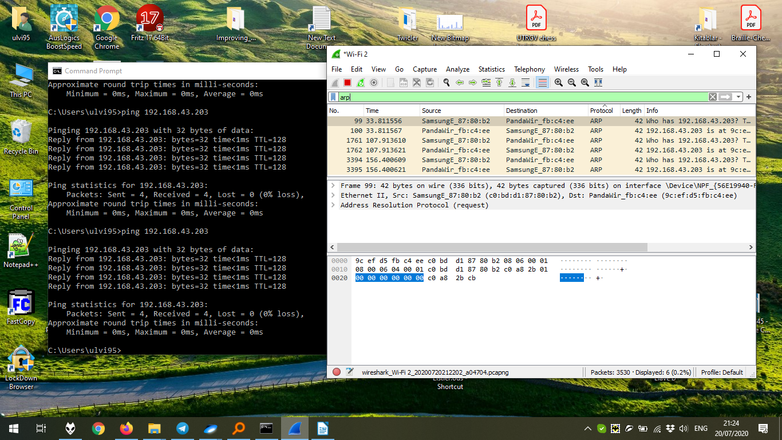

Filter TCP capture by **tcp** filter:

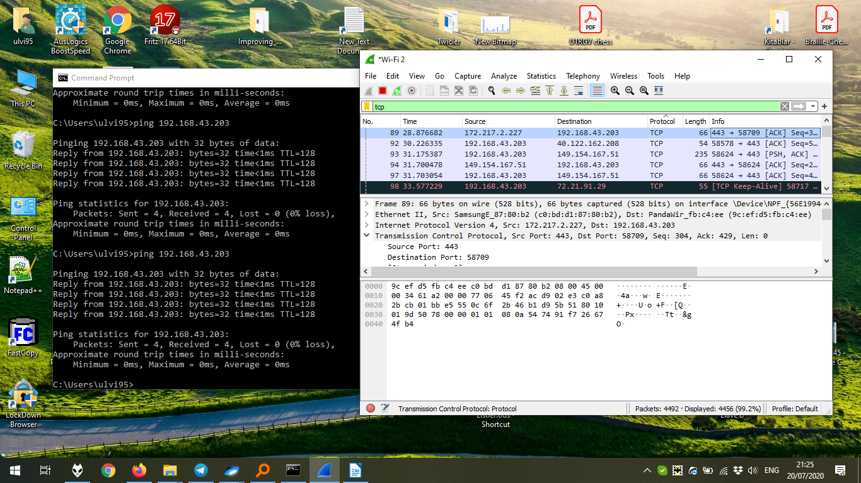

Filter HTTP capture by **http** filter. To communicate with HTTP, OCSP protocol is used.

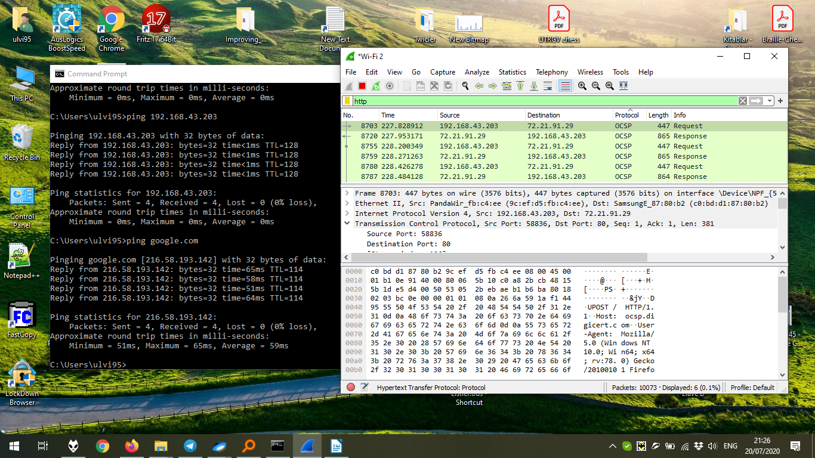

2) After getting to the site, we can see the cookies. For this, we should find POST requests of HTTP. After that, we can get the information.

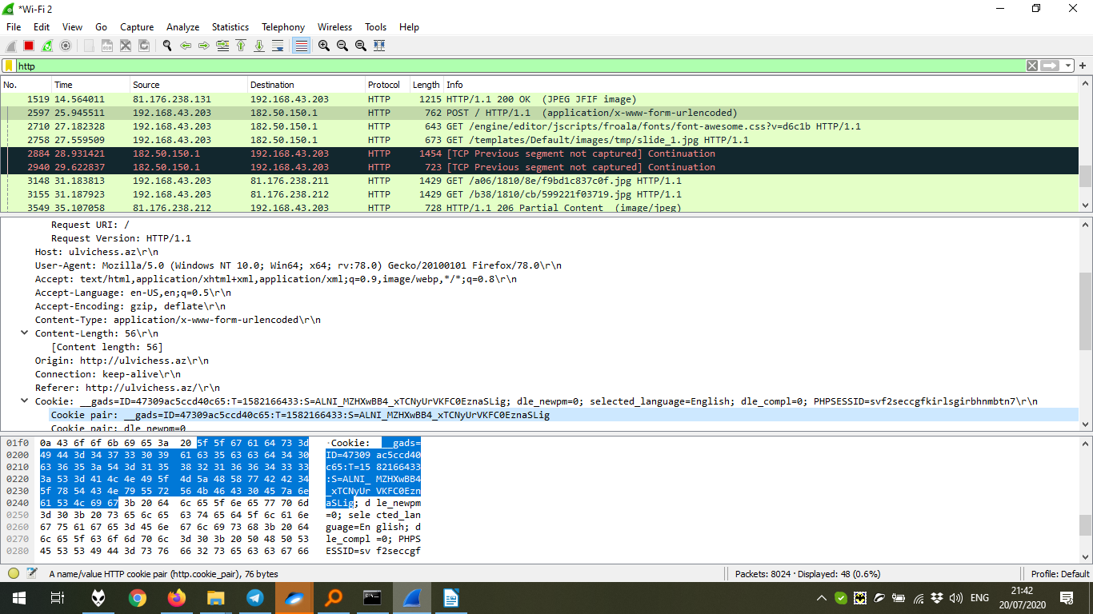

To capture the cookie with the username and the password, we can follow TCP stream of cookie by **Analyze -> Follow -> TCP Stream**, because most of the sites don’t have the crypted information. Here, we can find the information. In the screenshot below, I have blurred them.

